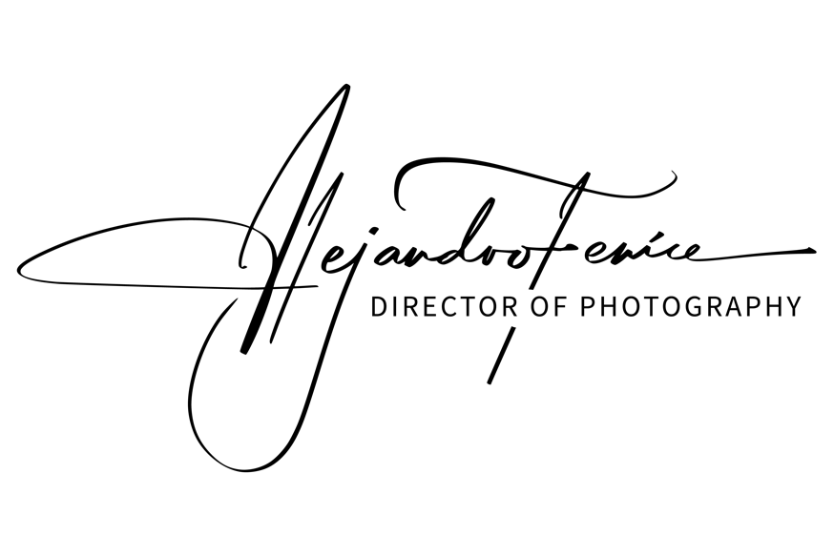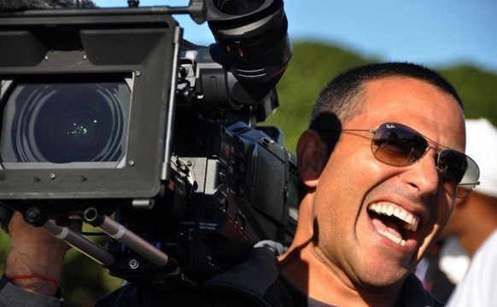**4250 Biscayne Blvd #902**

**Miami, fl 33137**

**Phone: (786)2851821**

**email: alejandrofenice@me.com**

**EXPERIENCE**

**DIRECTOR OF PHOTOGRAPHY – CAMERA OP – DRONE OPERATOR**

* **Ready To Love Detroit (Season 12)** (DP) ONW Network 2024
* **Ready To Love Philadelphia REUNION (Season 11)** (DP) ONW Network 2024
* **Ready To Love Philadelphia (Season 11)** (DP) ONW Network 2024
* **Ready To Love - Make a Move REUNION** (DP) ONW Network 2024
* **Ready To Love Dallas – REUNION (Season 9-10)** (DP) ONW Network 2023
* **Ready To Love Dallas (Season 9-10)** (DP) ONW Network 2023
* **Put A Ring On It** (DP) OWN Network 2022
* **The Most Expensive’s with Two Chainz** Miami Edition (DP) Vice 2022
* **Ready To Love Miami REUNION** (Season 7-8) (DP) OWN Network 2022
* **Ready To Love Miami** (Season 1-2) (DP) ONW Network 2022
* **NBA - MIAMI HEAT** Basketball Team (DP - Cam Op) NBA 2001- PRESENT
* **Love and Married DC** (DP) OWN Network 2022
* **NBC New Year’s Eve with Miley Cyrus and Pete Davidson** (Cam Op) NBC 2022
* **Love &Hip Hop MIAMI** (DP) (Season 4) VH1 2021
* **The Real Housewives of MIAMI** Cam Op (Season 4) Bravo 2021
* **Outdaughtered** (Director - DP) (Season 2-9) TLC 2016 – 2021
* **Darcey & Stacey Miami** (Cam Op) (Season 2) TLC 2021
* **Kevin Hart Presents Hart of the City** (DP) (Season 3) Comedy Central 2019
* **Comedians and Cocktails** (DP) (Season 1) LA 2019
* **Seeking Sister Wife** (DP) TLC 2017
* **The Real Housewives of New York** – MIAMI Episode (CamOp) Bravo 2016
* **She’s Got Game** MIAMI (Cam Op) VH1 (2016)
* **La Banda** (Cam Op) (Season 1-2) UNIVISION (2015 – 2016)
* **La Voz Kids** (Cam Op) (Season1-2-3) TELEMUNDO (2014-2015-2016)
* **Extraordinary Homes** (DP) HGTV (2015)
* **Yo Soy El Artista** (Cam Op) TELEMUNDO (2014)
* **1 Million Dollar Listing** MIAMI (Cam Op) Bravo (2014)
* **Find Me My Man** (DP) Oxigen (2014)
* **Swap Celebrity Wives** MIAMI (DP) ABC (2014)
* **The T.O. Show** (Cam Op) VH1 (2014)
* **Quiero Mis Quinces** (DP) (Season 1-6) MTV Tres (2012-2014)
* **Quiero Mi Boda** ( Director - DP) (Season 1-3) MTV Tres (2013-2014)
* **Quiero Mi Bebe** ( Director - Dp) (Season 1-2) MTV Tres (2013-2014)
* **Project Runway Latino America** (DP) Fashion TV (2013)
* **Russian’s Next Top Model** ( Director - DP) CTC RUSSIA (2013)

**REFERENCES ARE AVAILABLE UPON REQUEST**